Font Clamp Calculator CSS Utility Classes

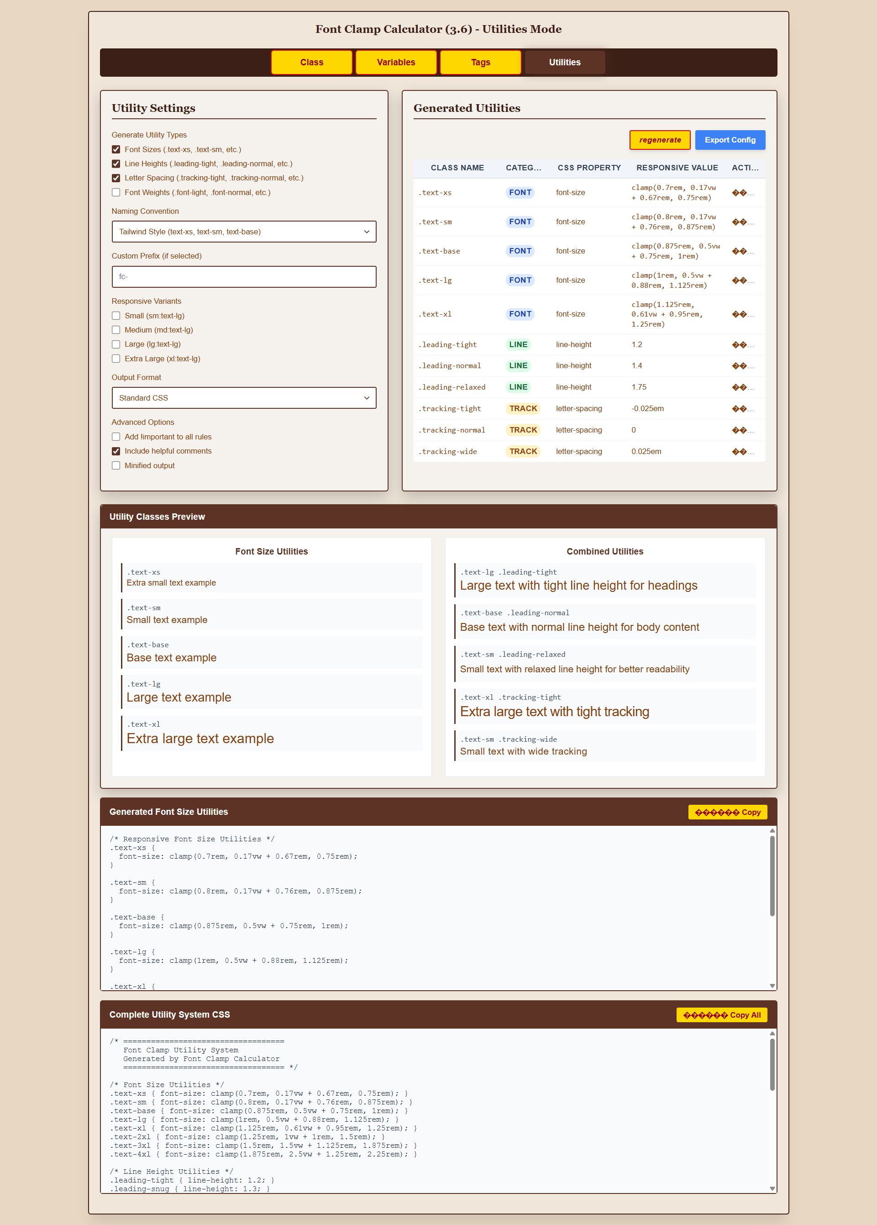

# Justification

**Why Utility Classes Fit Perfectly**

**1. Natural Extension of Your Current Work** Your tool already generates the mathematical foundation - utility classes would just package it differently:

css

*/* Current Class Mode */*

.medium { font-size: clamp(0.875rem, 0.5vw + 0.75rem, 1rem); line-height: 1.4; }

*/* New Utility Mode */*

.text-base { font-size: clamp(0.875rem, 0.5vw + 0.75rem, 1rem); }

.leading-normal { line-height: 1.4; }

.tracking-normal { letter-spacing: 0; }

**2. Addresses Modern Developer Workflow** Your tool already has the three paradigms (Classes, Variables, Tags), but utilities would complete the ecosystem:

* **Classes** = Component-based styling
* **Variables** = Custom property system
* **Tags** = Automatic HTML styling
* **Utilities** = Atomic, composable styling ← Missing piece!

**3. Leverages Your Mathematical Foundation** Your scale calculations and constants system would generate a complete utility system:

css

*/* Font Size Utilities */*

.text-xs { font-size: clamp(0.7rem, 0.17vw + 0.67rem, 0.75rem); }

.text-sm { font-size: clamp(0.8rem, 0.17vw + 0.76rem, 0.875rem); }

.text-base { font-size: clamp(0.875rem, 0.5vw + 0.75rem, 1rem); }

.text-lg { font-size: clamp(1rem, 0.5vw + 0.88rem, 1.125rem); }

*/* Line Height Utilities */*

.leading-tight { line-height: 1.2; }

.leading-normal { line-height: 1.4; }

.leading-relaxed { line-height: 1.75; }

*/* Letter Spacing Utilities */*

.tracking-tight { letter-spacing: -0.025em; }

.tracking-normal { letter-spacing: 0; }

.tracking-wide { letter-spacing: 0.025em; }

**Implementation Suggestions**

**Add a 4th Tab: "Utilities"**

php

*// In your existing tab system*

<button id="utilities-tab" class="tab-button" data-tab="utilities">Utilities</button>

**Extend Your Data Structure**

php

const OPTION_UTILITY_CONFIG = 'font_clamp_utility_config';

private function create_default_utility_config() {

return [

'generateFontSizes' => true,

'generateLineHeights' => true,

'generateLetterSpacing' => true,

'generateFontWeights' => false, *// Optional*

'prefix' => '', *// Allow custom prefix like 'fc-'*

'includeResponsive' => true *// Generate sm:, md:, lg: variants*

];

}

**Enhanced CSS Generation** Your existing generateClampCSS() function could power multiple utility types:

javascript

generateUtilityCSS() {

let css = '';

*// Font sizes (your existing logic)*

sizes.forEach(size => {

css += `.text-${size.name} { font-size: ${generateClampCSS(size.min, size.max)}; }\n`;

});

*// Line heights*

css += `.leading-tight { line-height: 1.2; }\n`;

css += `.leading-normal { line-height: 1.4; }\n`;

css += `.leading-relaxed { line-height: 1.75; }\n`;

*// Letter spacing based on your scale*

css += `.tracking-tight { letter-spacing: -0.025em; }\n`;

css += `.tracking-normal { letter-spacing: 0; }\n`;

css += `.tracking-wide { letter-spacing: 0.025em; }\n`;

return css;

}

**Why This Is Smart Strategy**

**1. Market Demand**: Utility-first CSS is hugely popular (Tailwind, Tachyons, etc.)

**2. Differentiator**: Most clamp generators only do font-size - you'd offer complete utility systems

**3. User Value**: Developers get production-ready utility classes, not just individual font sizes

**4. Framework Integration**: Your utilities could complement or replace Tailwind's typography utilities with better responsive math

**5. Future-Proof**: Utilities work with any framework/methodology

**Competitive Advantage**

This would make your tool significantly more valuable than typical clamp calculators because you'd be generating **complete design systems**, not just individual CSS rules. The combination of your mathematical foundation + utility packaging would be quite powerful.

# Implementation Plan

Here's a comprehensive implementation plan that builds on your existing foundation:

**Phase 1: Backend Architecture Extensions**

**1.1 Database/Options Schema**

php

*// Add to your existing constants*

const OPTION_UTILITY_CONFIG = 'font_clamp_utility_config';

const OPTION_UTILITY_SIZES = 'font_clamp_utility_sizes';

private function create_default_utility_config() {

return [

'enabledTypes' => [

'fontSize' => true,

'lineHeight' => true,

'letterSpacing' => true,

'fontWeight' => false

],

'namingConvention' => 'tailwind', *// 'tailwind', 'bootstrap', 'custom'*

'customPrefix' => '',

'responsiveVariants' => [

'sm' => false,

'md' => false,

'lg' => false,

'xl' => false

],

'outputFormat' => 'css', *// 'css', 'scss', 'less', 'stylus'*

'advancedOptions' => [

'importantRules' => false,

'cssComments' => true,

'minified' => false

]

];

}

private function create_default_utility_sizes() {

return [

*// Generated from your existing size system*

*// This will be populated dynamically from classSizes*

];

}

**1.2 Core Class Extensions**

php

*// Add to FontClampCalculator class*

private $default_utility_config;

private $default_utility_sizes;

*// In init_defaults()*

$this->default_utility_config = $this->create_default_utility_config();

$this->default_utility_sizes = $this->create_default_utility_sizes();

*// New getters*

public function get_font_clamp_utility_config() {

static $cached_config = null;

if ($cached_config === null) {

$cached_config = get_option(self::OPTION_UTILITY_CONFIG, $this->default_utility_config);

}

return $cached_config;

}

public function get_font_clamp_utility_sizes() {

static $cached_sizes = null;

if ($cached_sizes === null) {

$cached_sizes = get_option(self::OPTION_UTILITY_SIZES, $this->default_utility_sizes);

}

return $cached_sizes;

}

**1.3 AJAX Handler Extensions**

php

*// Extend existing save_settings() method*

public function save_settings() {

*// ... existing validation code ...*

*// Add utility config handling*

if (isset($_POST['utilityConfig'])) {

$utility_config_json = stripslashes($_POST['utilityConfig']);

$utility_config = json_decode($utility_config_json, true);

if (json_last_error() === JSON_ERROR_NONE) {

update_option(self::OPTION_UTILITY_CONFIG, $utility_config);

}

}

*// ... rest of existing save logic ...*

}

**Phase 2: Frontend Architecture Extensions**

**2.1 JavaScript Class Extensions**

javascript

*// Extend FontClampAdvanced class*

class FontClampAdvanced {

constructor() {

*// ... existing constructor code ...*

this.utilityConfig = this.initializeUtilityConfig();

this.generatedUtilities = [];

}

initializeUtilityConfig() {

return window.fontClampAjax?.data?.utilityConfig || {

enabledTypes: {

fontSize: true,

lineHeight: true,

letterSpacing: true,

fontWeight: false

},

namingConvention: 'tailwind',

customPrefix: '',

responsiveVariants: {},

outputFormat: 'css',

advancedOptions: {}

};

}

*// New utility generation methods*

generateUtilities() {

this.generatedUtilities = [];

if (this.utilityConfig.enabledTypes.fontSize) {

this.generateFontSizeUtilities();

}

if (this.utilityConfig.enabledTypes.lineHeight) {

this.generateLineHeightUtilities();

}

if (this.utilityConfig.enabledTypes.letterSpacing) {

this.generateLetterSpacingUtilities();

}

if (this.utilityConfig.enabledTypes.fontWeight) {

this.generateFontWeightUtilities();

}

this.renderUtilitiesTable();

this.updateUtilitiesCSS();

}

generateFontSizeUtilities() {

const sizes = this.getCurrentSizes();

const convention = this.utilityConfig.namingConvention;

sizes.forEach(size => {

const className = this.getUtilityClassName(size, 'fontSize', convention);

const clampValue = this.generateClampCSS(size.min, size.max);

this.generatedUtilities.push({

id: `fs-${size.id}`,

className: className,

category: 'fontSize',

property: 'font-size',

value: clampValue,

responsive: false

});

*// Generate responsive variants if enabled*

this.generateResponsiveVariants(className, 'font-size', clampValue);

});

}

getUtilityClassName(size, type, convention) {

const mapping = {

tailwind: {

fontSize: this.getTailwindFontSizeName(size),

lineHeight: this.getTailwindLineHeightName(size),

letterSpacing: this.getTailwindTrackingName(size)

},

bootstrap: {

fontSize: `fs-${size.id}`,

lineHeight: `lh-${size.id}`,

letterSpacing: `ls-${size.id}`

},

custom: {

fontSize: `${this.utilityConfig.customPrefix}text-${size.id}`,

lineHeight: `${this.utilityConfig.customPrefix}leading-${size.id}`,

letterSpacing: `${this.utilityConfig.customPrefix}tracking-${size.id}`

}

};

return mapping[convention][type] || `utility-${size.id}`;

}

}

**2.2 UI Component Extensions**

javascript

*// Extend handleTabChange method*

handleTabChange(detail) {

*// ... existing tab change code ...*

if (detail.activeTab === 'utilities') {

this.showUtilitiesInterface();

this.generateUtilities();

} else {

this.hideUtilitiesInterface();

}

}

showUtilitiesInterface() {

*// Show utilities-specific UI elements*

document.getElementById('utilities-settings')?.classList.remove('hidden');

document.getElementById('utilities-table')?.classList.remove('hidden');

document.getElementById('utilities-preview')?.classList.remove('hidden');

}

**2.3 HTML Template Extensions**

php

// Add to your existing render_admin_page() method

private function render_utilities_tab($data) {

$utility_config = $this->get_font_clamp_utility_config();

ob_start();

?>

<div id="utilities-content" class="tab-content" style="display: none;">

*<!-- Utilities Settings Panel -->*

<div id="utilities-settings" class="fcc-panel">

<h2>Utility Settings</h2>

*<!-- Utility Types Checkboxes -->*

<div class="setting-group">

<label>Generate Utility Types</label>

<div class="checkbox-group">

<input type="checkbox" id="enable-font-sizes"

<?php echo $utility_config['enabledTypes']['fontSize'] ? 'checked' : ''; ?>>

<label for="enable-font-sizes">Font Sizes</label>

</div>

*<!-- ... more checkboxes ... -->*

</div>

*<!-- Naming Convention -->*

<div class="setting-group">

<label for="naming-convention">Naming Convention</label>

<select id="naming-convention">

<option value="tailwind" <?php selected($utility_config['namingConvention'], 'tailwind'); ?>>

Tailwind Style

</option>

<option value="bootstrap" <?php selected($utility_config['namingConvention'], 'bootstrap'); ?>>

Bootstrap Style

</option>

<option value="custom" <?php selected($utility_config['namingConvention'], 'custom'); ?>>

Custom Prefix

</option>

</select>

</div>

*<!-- ... more settings ... -->*

</div>

*<!-- Utilities Table -->*

<div id="utilities-table" class="fcc-panel">

*<!-- Generated dynamically by JavaScript -->*

</div>

</div>

<?php

return ob_get_clean();

}

**Phase 3: Implementation Timeline**

**Week 1: Foundation**

* Add database schema extensions
* Implement utility config getters/setters
* Extend AJAX save handlers
* Add utilities tab to existing interface

**Week 2: Core Generation Logic**

* Implement generateUtilities() methods
* Create utility naming convention mappings
* Build CSS generation for utilities
* Add responsive variant generation

**Week 3: UI Integration**

* Create utilities settings panel
* Build utilities table component
* Implement utilities preview
* Add copy functionality for utilities

**Week 4: Advanced Features**

* Add output format options (SCSS, Less, etc.)
* Implement responsive variants
* Add export/import functionality
* Optimize performance and add caching

**Week 5: Testing & Polish**

* Cross-browser testing
* Performance optimization
* Documentation updates
* User acceptance testing

**Phase 4: Data Flow Architecture**

User Input (Settings)

↓

Utility Config Update

↓

Size Calculations (existing logic)

↓

Utility Generation (new logic)

↓

CSS Output (extended logic)

↓

Database Save (extended AJAX)

**Phase 5: Risk Mitigation**

**Backward Compatibility**

* All existing functionality remains unchanged
* Utilities are additive, not replacement
* Database migrations handle missing options gracefully

**Performance Considerations**

* Utility generation cached until settings change
* Debounced regeneration (300ms like existing code)
* Pagination for large utility sets

**Code Maintainability**

* Utilities extend existing patterns, don't replace them
* Same constants system used throughout
* Same styling and interaction patterns

**Phase 6: Future Extensibility**

The architecture supports future additions:

* **Color utilities** (using your color palette manager concept)
* **Spacing utilities** (using your space clamp calculator concept)
* **Animation utilities**
* **Framework-specific exports** (Tailwind config, Bootstrap SCSS)

**Resource Requirements**

* **Development Time**: ~5 weeks (1 developer)
* **Testing Time**: ~1 week
* **No additional dependencies** (uses existing WordPress/PHP/JavaScript stack)
* **Database Impact**: Minimal (2 new options)

This plan leverages your existing architecture while adding significant value through utility generation. The key insight is that utilities are just a different **packaging** of your existing mathematical calculations - same foundation, different output format.